Data Mapper to update data into SObject(Account, Claim, Insurance Policy)

DataMapper Name: DR_claimForm

It is the part of our guided journey where in last step before Email Send we have to save our all data back into Salesforce SObject (Account, Claim, InsurancePolicy).

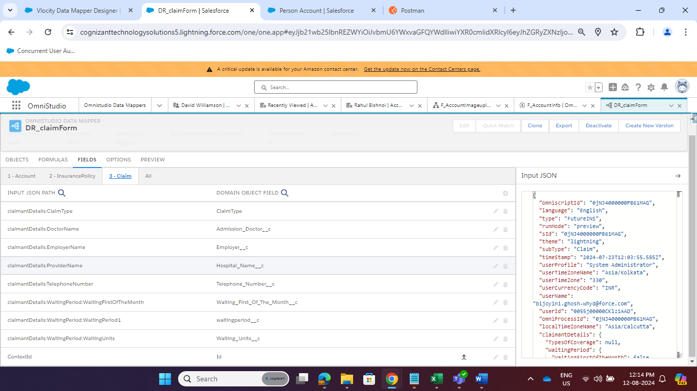

For Saving these all data I use the JSON where I get Account Id in AccountId , Claim Id in ClaimId and Policy Insurance Id in PolicyNumber1 (I will get this json from data Mapper Extract)

Only important Filed I Mapped.